Data Cleaning & Geographic Categorization
Categorizes customer locations into regional cohorts (West, South, North, East, or Other/Unknown) based on their state using conditional logic while handling missing values.
Creates the geographic cohorts view to filter successful e-commerce transactions and standardize column names (order_d, customer_id, order_amount). Categorizes customer locations into regional cohorts (West, South, North, East, and Other/Unknown) using CASE logic while replacing missing state values with COALESCE. Outputs a clean table mapping each successful order and customer to their assigned geographic region for downstream analysis.
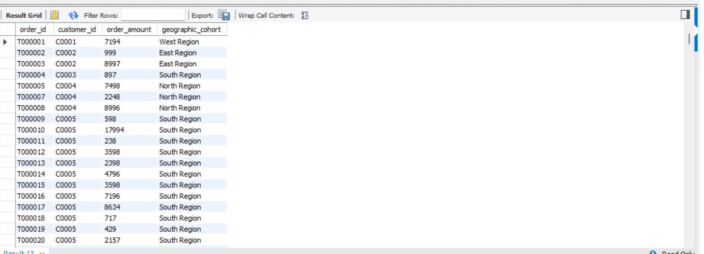
QUERY-;
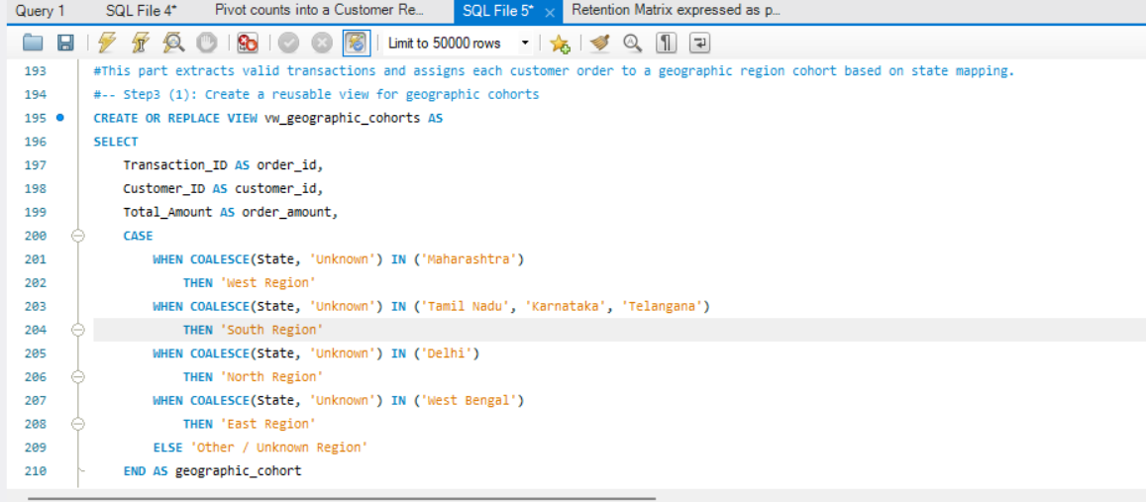

OUTPUT-;

